API_LINK: https://eman123yasser-tests-ocr-dd7dfd9.hf.space
Reading End Point:
{
test_name:””,
confidence:””,
test_values

Input

OCR TEST READING MODEL
Output

Test Name, Image.

- CBC TEST
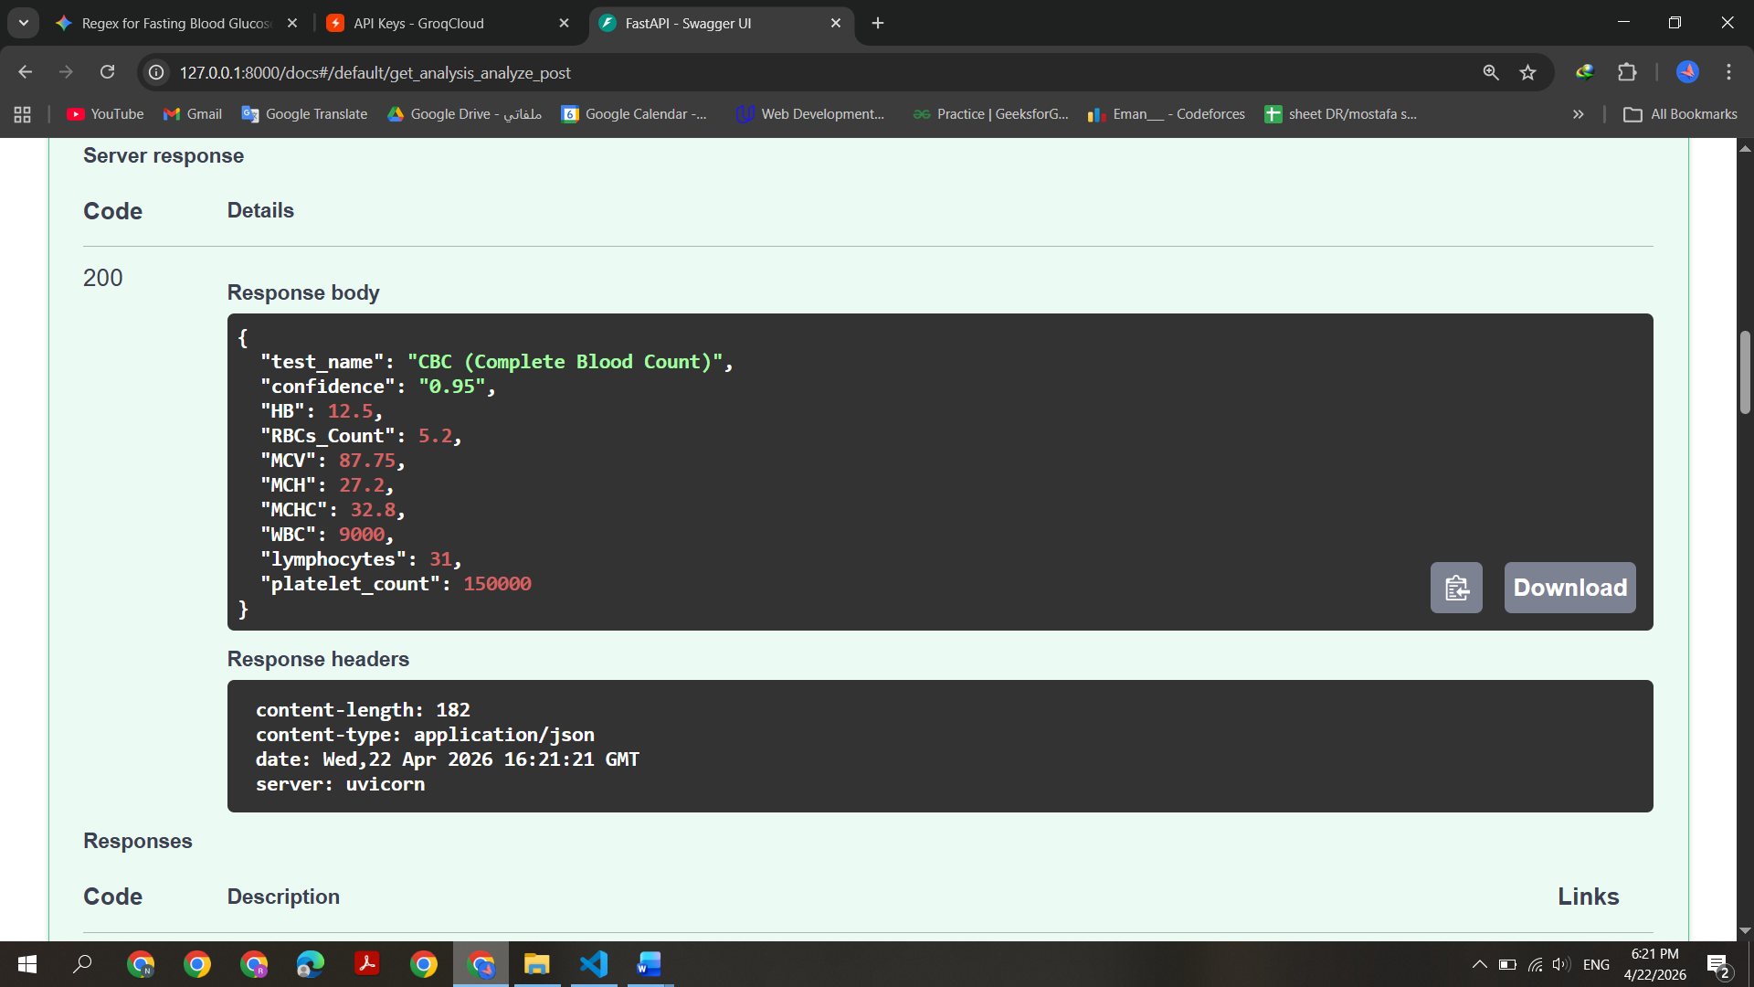

- Urinalysis
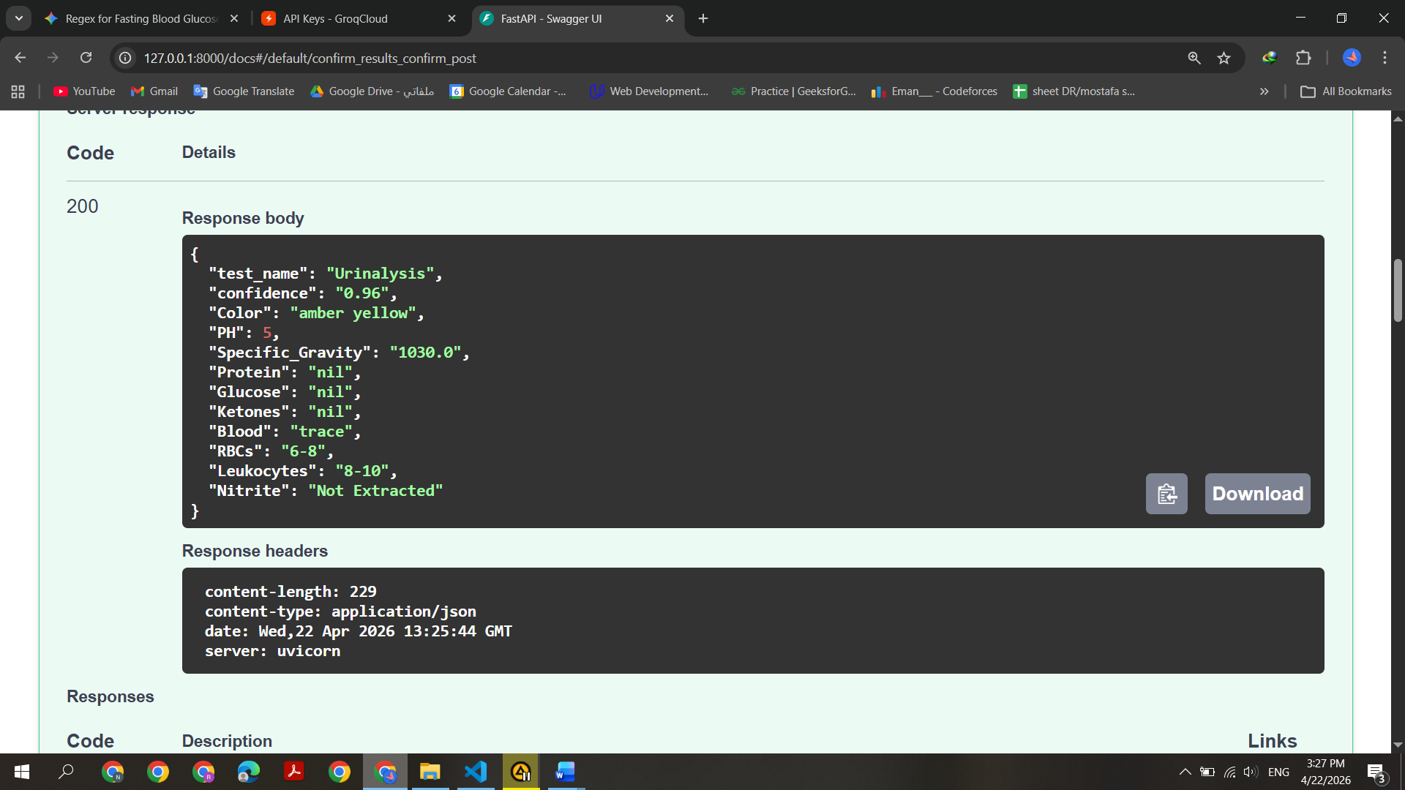

- TSH
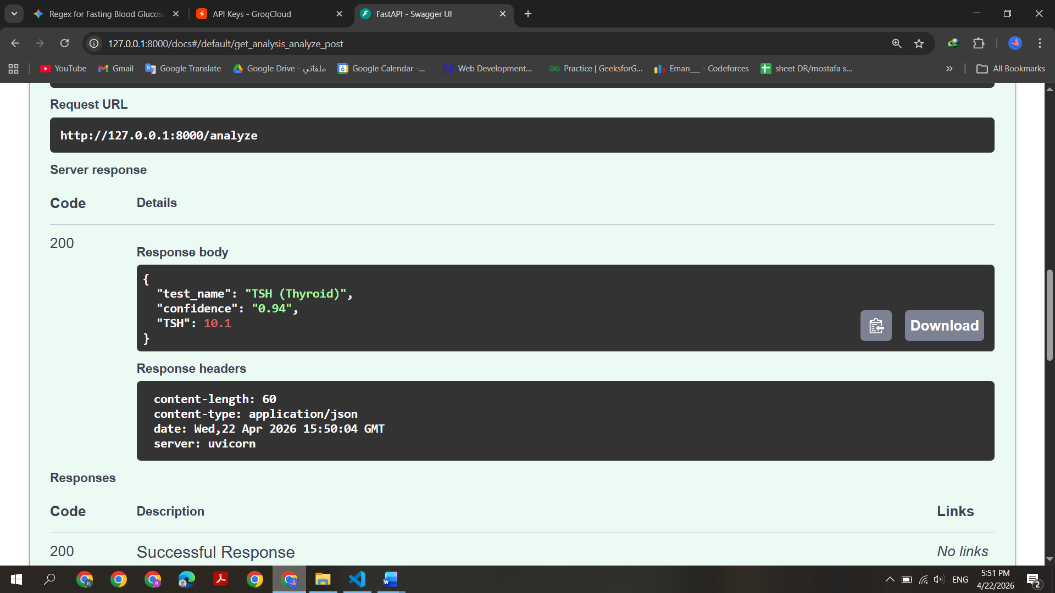

- Ferritin
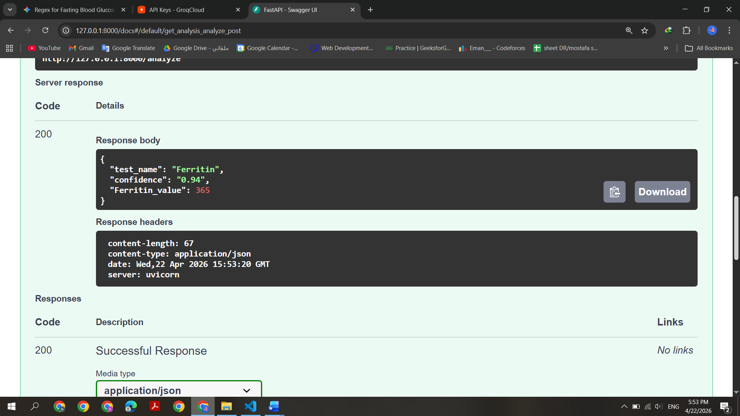

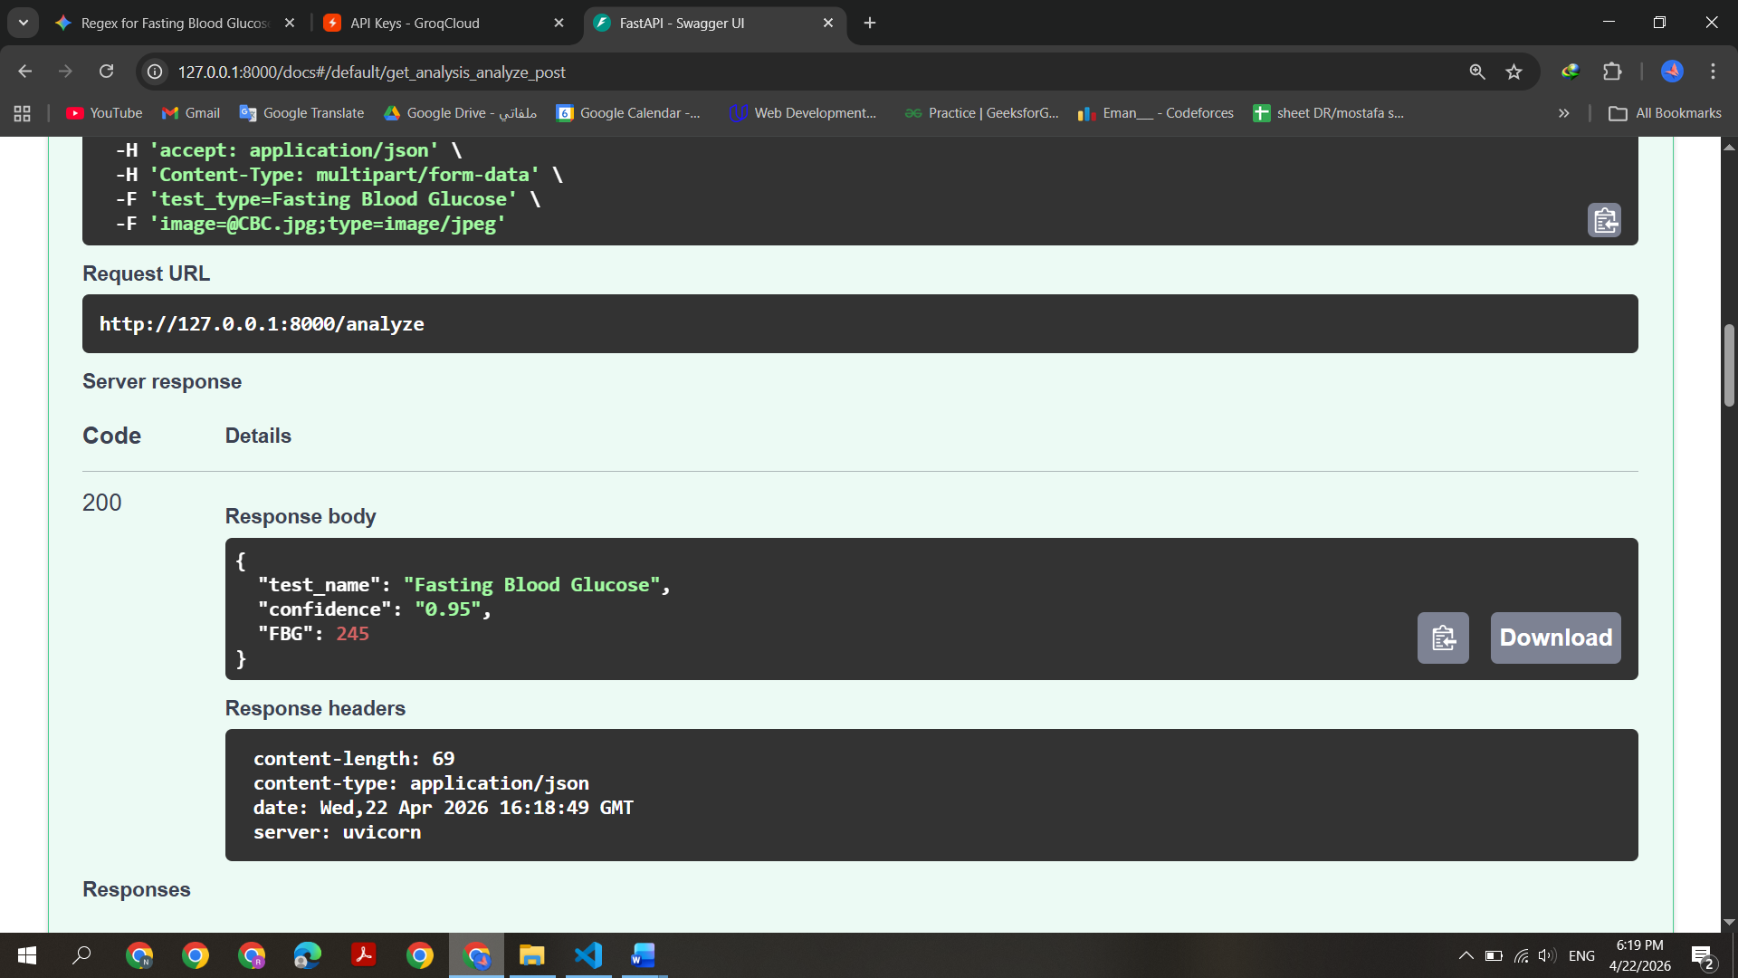
- Fasting Blood Glucose

- HbA1c
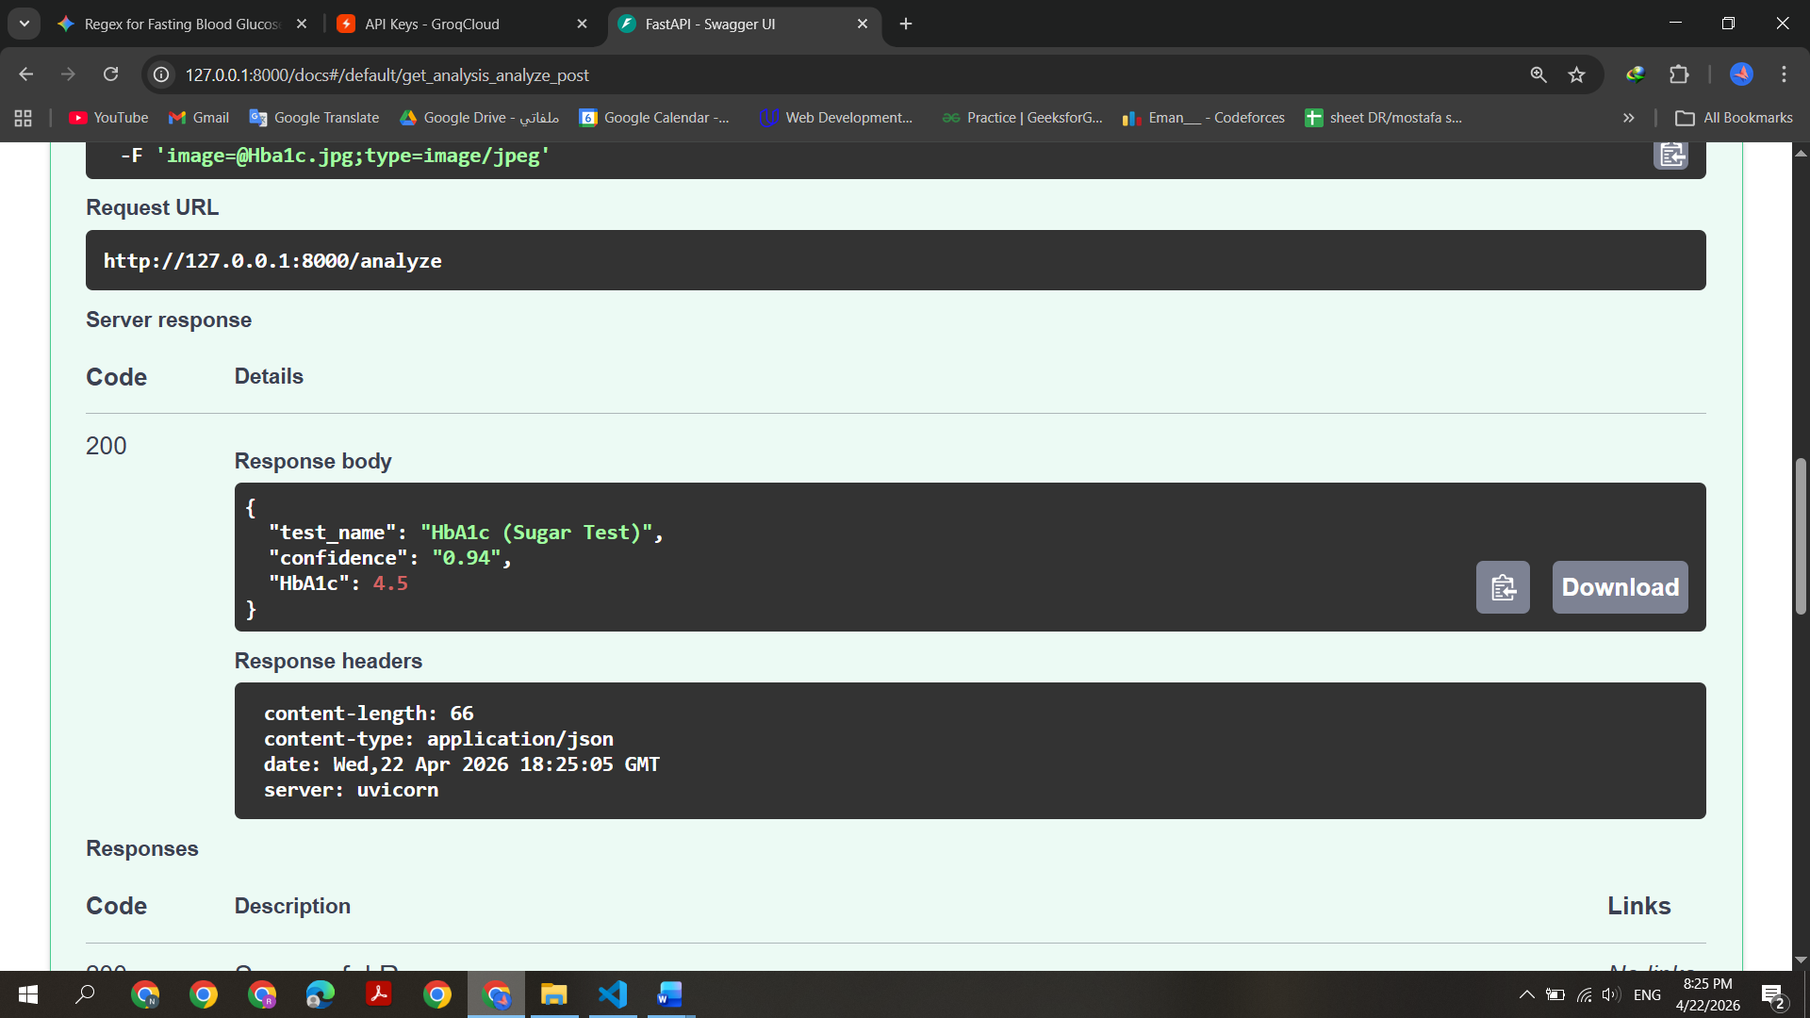
- Blood Group
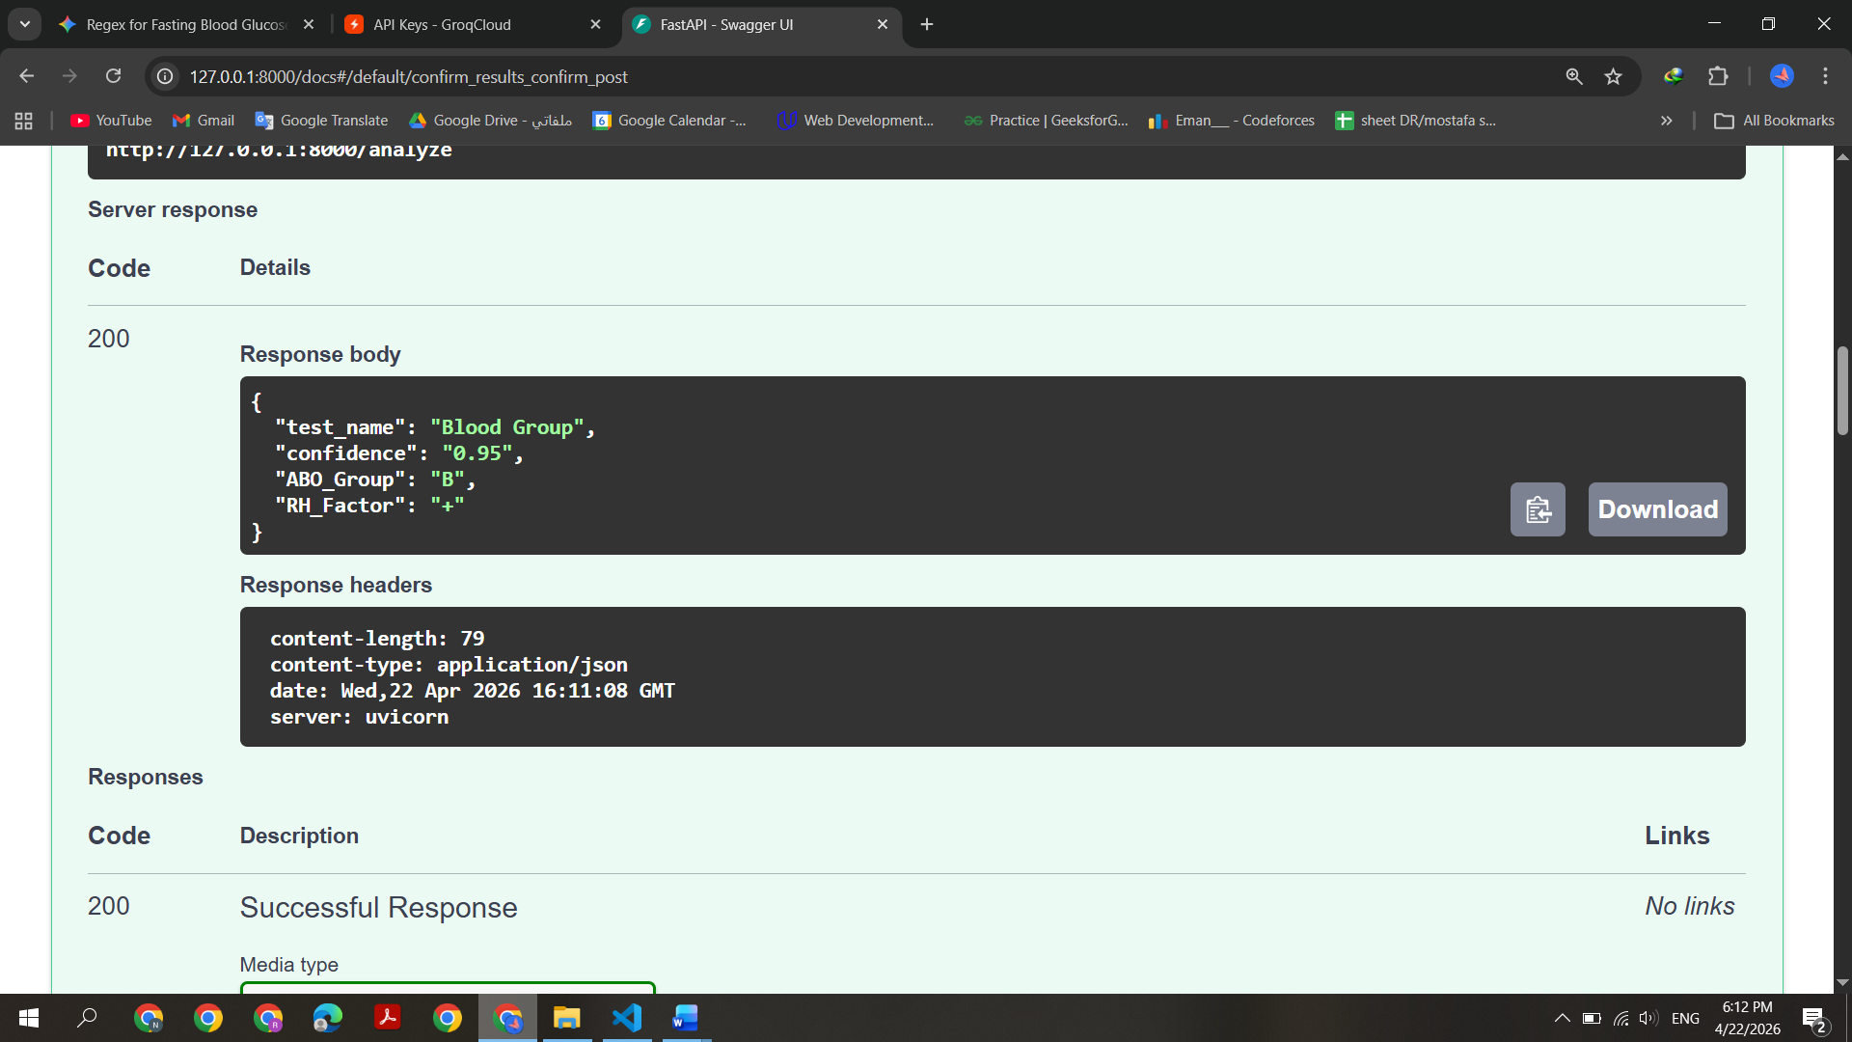
- Hepatitis B
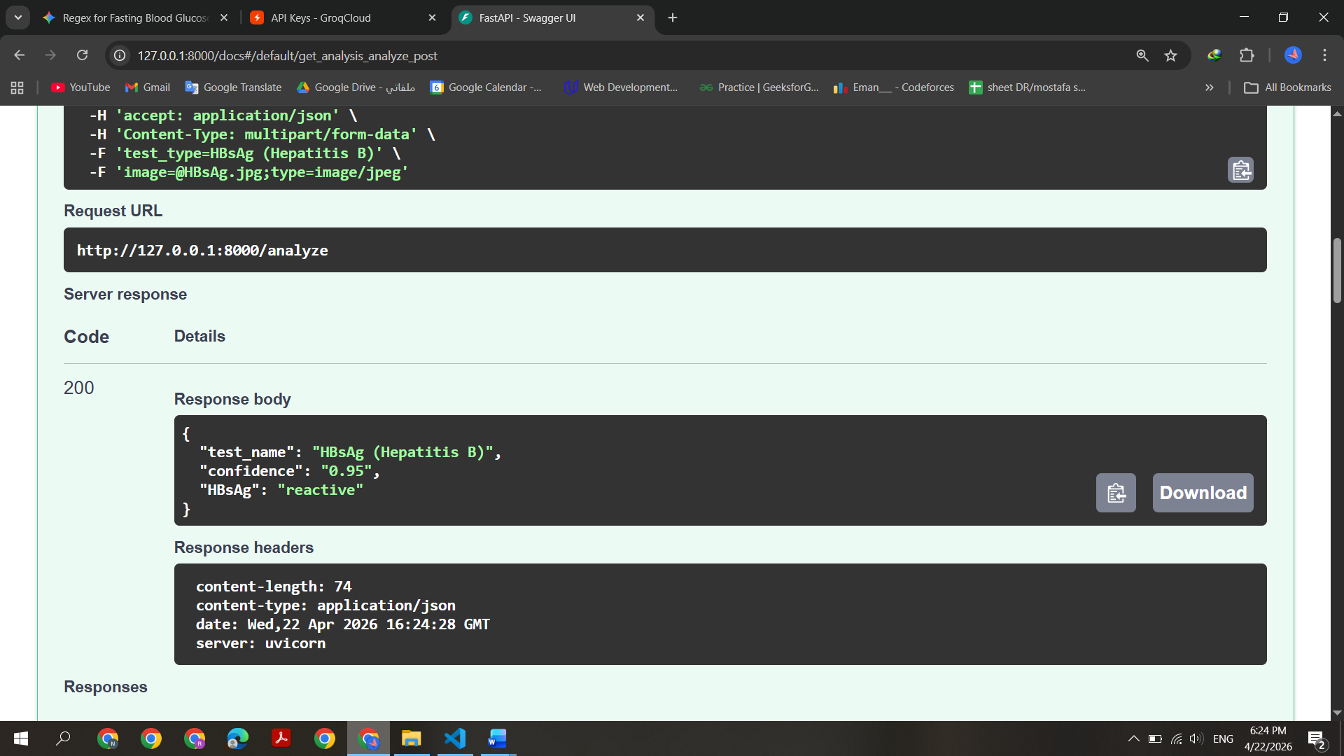
- Hepatits C
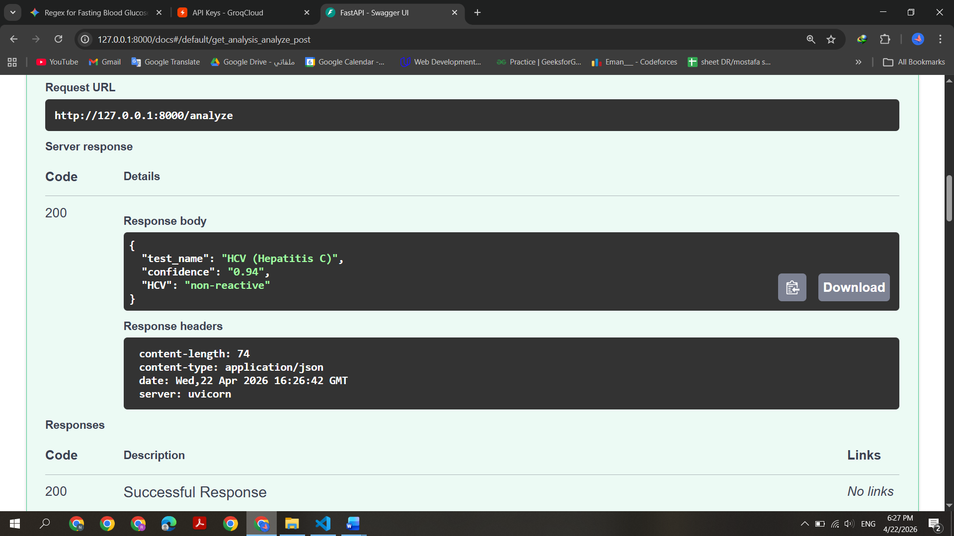

Test | Duration
CBC | Every 4 weeks
Urine | Every 4 weeks
Ferritin | Every 4 weeks
TSH | Every 4 weeks
Fasting blood glucose | Every 4 weeks
HgA1c | Every 3 Months
Blood Group | Just once start from the week 25
Hepatitis B | Based on Doctor Need
Hepatitis C | Based on Doctor Need
Conformation End Point:
Error Message
{
test_name:””,
confidence:””,
test_values

Output

Input

Verification & Confirmation Step
{
test_name:””,
confidence:””,
test_values

Confidence, Verified Specific important values

- Store IN: DataBase
- In Usual: Number: float, -1 OR Text
- Just for Positive / Negative Values

